PANTHERETTE PARENT AUDITION PERMISSION FORM
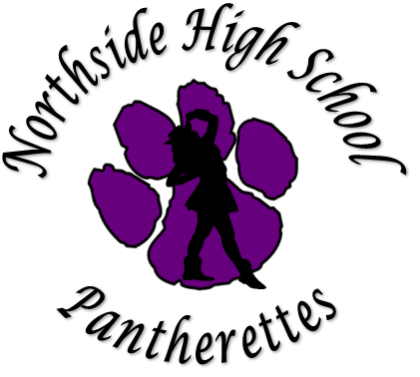

Dear Pantherette Candidate Parent/Guardian,
We are excited to know that your child is interested in becoming a member for the Northside HS Pantherette Dance/Drill Team. Northside HS Pantherettes are often seen as role models on our campus and they need to have passing grades to be an active member of our organization. It is important for each member to consistently be respectful, poised, well-mannered, and exhibit good judgment. This responsibility extends to social media as well.
We are one of the few organizations that actively participate in year-long activities; from football season to summer rehearsals. The Pantherettes also participate in yearly district and non-district dance competitions, so many times long hours of rehearsals are necessary.
Hence, Pantherettes are student athletes so it is imperative for each member to maintain at least a 70 average in each of their classes in order to be eligible to be an active member.
It is our hope that you allow your child to audition for the Northside HS Pantherettes for the 2021-2022 season. If so, please do so by signing the form below and returning it with your child.

Ms. Sandra Reyna-Urbina and Mr. Francisco Rodriguez
Pantherette Directors

Parent Agreement (sign and return)
I have reviewed the information above and understand the time, dedication and monetary requirements that comes with being a Northside HS Pantherette. I support my child in her/his decision to audition to become a member of the Pantherette Organization. I understand that the audition will be done virtually this spring semester.
Pantherette Name (printed):
Parent Name (printed):
Parent Signature: Date:

